Welcome to a New Season!
Our new season is in full swing and we would like to thank all our new and returning members for making our 2016-2017 membership drive a wonderful success. It's encouraging to see so many new Junior skaters on the ice as the arena fills up every afternoon around four with our skaters.

Our Senior skaters do not stop amazing us either, they competed at The 2016 Canmore Fall Invitational in September bringing home several medals. Coach Natasha Taylor is beginning to attract provincial attention to the club through her work with her competitive skaters, most recently Dawson Nodwell was invited to a National Skate Camp and is landing his triple Lutz!

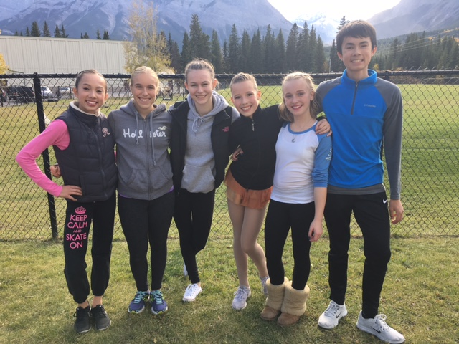
Happy “Seniors” after a successful competition in Canmore this September

Our CanSkate program has started with a great success as well, the newly redesigned program is lead by Kate MacDonald along with Nationally Certified Coaches and assisted by eager program assistants - all keen skaters from our club!
Behind the Scenes

The Skaters’ change room received a well deserved update over the summer, thank you Cheryl Burges for your hard work on the design and contracting process!

Joe Philips Arena is now equipped with a new sound system, and a new harness for our skaters training on their jumps.

The SFSC Board, lead by our new president Karla Dolaptchiev, is working hard at making this upcoming season all that you expected from a club and more.

Our Programs
CanSkate…
…runs Thursdays and Saturdays. Designed to develop basic skating skills. CanSkate is also great for little hockey players - our program is officially linked with Hockey Canada for skating development!
For more details please contact Kate MacDonald at s.katemacdonald@gmail.com
Junior-Prep.
Open to skaters of all ages, who are working on a CanSkate-Level 4 badge.
You can also contact Kailee Myhill, our Technical Director at springbankskating@gmail.com 403-616-7909
STARSkate / Competitive

Skills, Tests, Achievement, and Recognition = STARSkate.
You can also contact Kailee Myhill, our Technical Director at springbankskating@gmail.com 403-616-7909

Upcoming Events

Winter Carnival, December 15th and December 17th
Once again, SFSC will host two nights when all our skaters can show their talents, and celebrate the Season!
Technical Director (TD)
In her new position as a TD, Kailee Myhill will provide oversight and coordination of the StarSkate- and Competitive Skating programs. Kailee is a very successful coach with our club, and now she will take on this position to ensure smooth delivery of the programs. Contact Kailee with any questions at springbankskating@gmail.com 403-616-7909.
Coaches' Corner
We would like to express our gratitude to one of our dear head coaches, Chelsey Philips, for the additional hours of time spent as our last season's coaches' representative. Chelsey is stepping down as a rep. to now fully focus on coaching our skaters again. Many Thanks!
Our new Coaches representative is Natasha Taylor, she is a National Level coach, trainer of provincial champions. Her skating achievements include Quad Gold level, and in 2010 she was a ISU Adult Champion. She held was our rep. a couple of years ago, and we're grateful to have her back in this role.
Please also visit our website at www.springbankskating.com or on Facebook at Springbank Figure Skating Club.

Contributed October 2016 by Eniko Kapocsi-Kiss & Gesche Tallen

